As our website is using the Django framework to handle the backend development, I started learning how to use this new tool for our purposes. My research includes but is not limited to the following tasks:

* The basic details about the history of Django and the reason it was required to be developed.
* Understanding what function Django serves for web development and how it differs from other similar tools.
* Being able to setup the software and tools needed to start working on a Django project.
* Being introduced to the command-line interface needed to install and manipulate Django itself and the project.
* Grasping the basic ideas of the default directory in a Django development environment and what purposes the different python files serve.
* Creating a project and then making a Django ‘app’ to begin working on the backend design.
* Running a local server provided by Django to see the live results of the development.
* Making sense of the regex required by the urls.py file that links the front end to the backend.
* Understanding how templating works in Django normally, and the other way we are using to make it more dynamic and efficient.
* Exploring the basic idea of backed-end rendered templating and front-end rendered templating.
* Getting started with models (tables) in the Django way to deal with the database that stores the information requested by users of the system.
* Using ORM (instead of SQL) to create models and migrate them to the project.
* Using the Django administration tool to view and manipulate data in the database.
* Our project layout

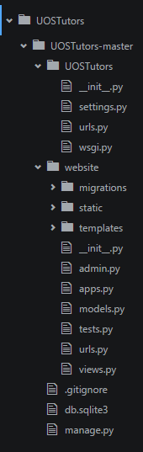

* This is a part of the HTML page that displays course information

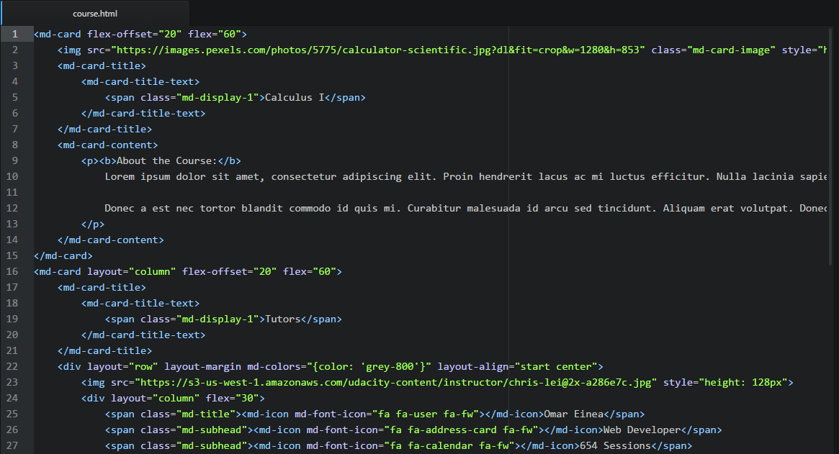

* We have created a table in our database called User. This is a superclass from which we will instantiate two other tables: Tutors and Tutee.

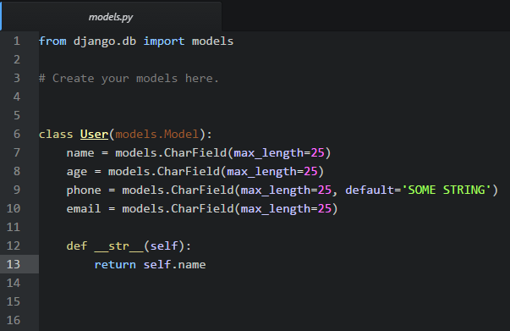

* urls.py file which is a file that handles URL dispatches. When a pattern matches the URL, it calls a function in the views.py file (e.g., views.checker) and that function renders a specific web page.

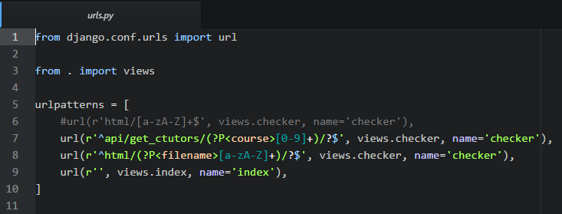

* views.py consists of functions that are used to render .html pages depending on the URL pattern that called it.

